Chapter 14, Solution 10.

Design a problem to help other students to better understand how to determine the Bode magnitude and phase plots of a given transfer function in terms of jω.

Although there are many ways to solve this problem, this is an example based on the same kind of problem asked in the third edition.

Problem

Sketch the Bode magnitude and phase plots of:

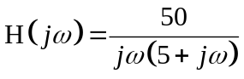

Solution

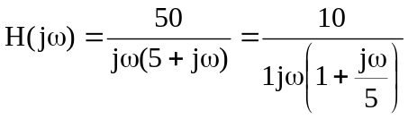

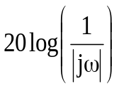
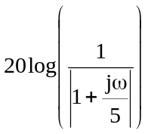
H_{dB}
-20
20
⬥
100
1
10
0.1
-40
40
20 log1

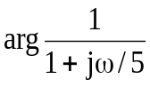
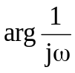

-135
-45
⬥
100
1
10
0.1
-180
-90

